

**MONSTER ENERGY BRITISH GRAND PRIX MOTOGP 2024**

Taxis are permitted to drop off and pick up from Car Park 49 at this year’s MotoGP event (W3W///Lordship.drift.twinkling).

Taxis and Private Hire Vehicles are welcome to park in our Official Public Car Parks for the day, but this parking must be purchased by a ticket holder in advance.

Please take note of the traffic systems in place as we have one-way systems in place during the event.

Additional Transportation Options

Shuttle Service operates to/from:

* Milton Keynes Train Station

Shuttle times for Train stations and Park & Ride:

|  |  |  |
| --- | --- | --- |
|  | SATURDAY | SUNDAY |
| To Circuit | 07:00 – 13:00 | 06:00 – 11:00 |
| From Circuit | 16:00 – 21:30 | 14:00 – 20:30 |

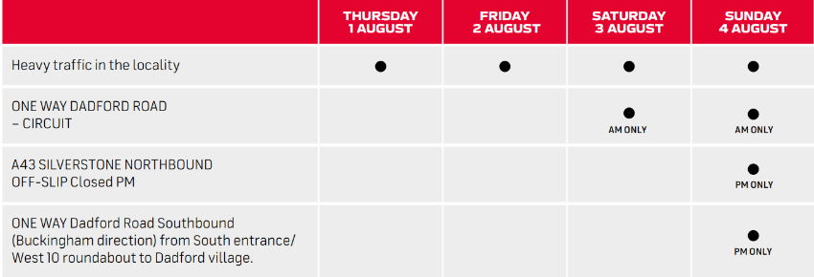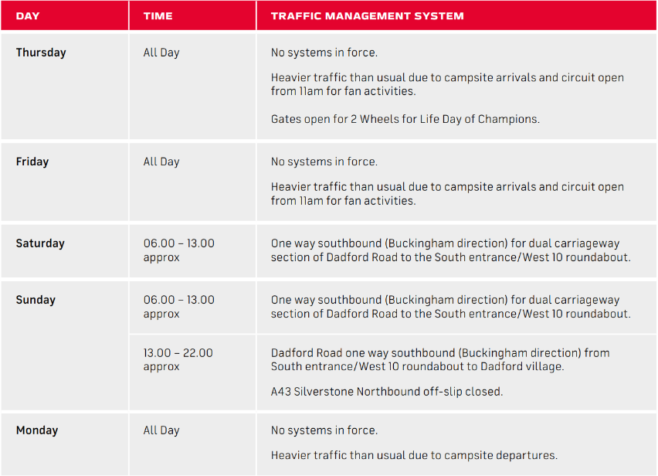**MotoGP Traffic Information:**